

**SPC405 - Project**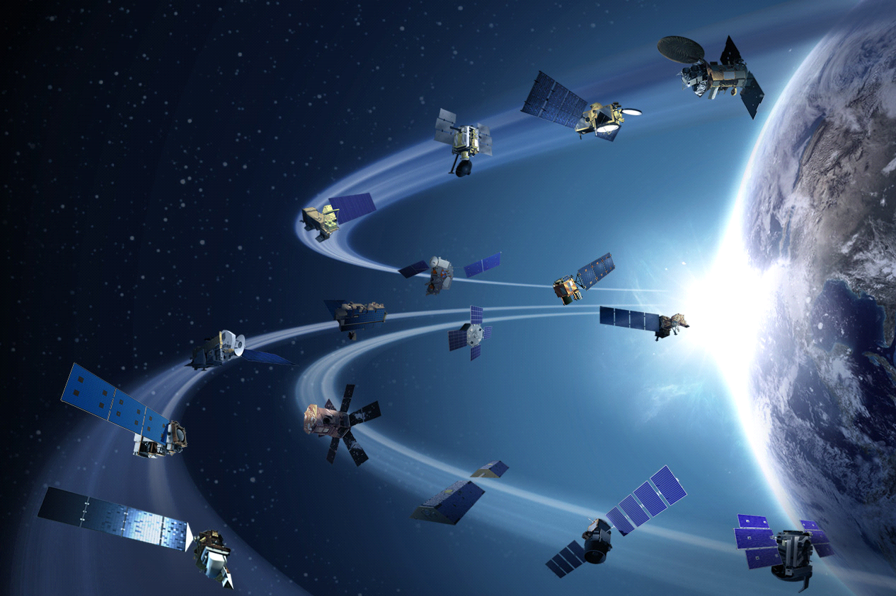

**Team-members Names: IDs:**

**Maha Ezzat 201400601  
 Shrouk Shalaby 201400455**

This program has three working modes;

* Mode (1) :

Takes the input from the user (whether in the form of 6 orbital elements, TLE, or initial R and V) to plot the orbit and animate the motion of the satellite.

* Mode (2) :

Takes the time at which the user wants to calculate the position and velocity (after taking the initial input from mode (1)) and calculates them.

* Mode (3) :

Is the interplanetary transformation: the user chooses the destination planet (Mars or Venus) and enters the radii of both parking orbits then the program generates a 3d animation of the interplanetary transformation.

**Notes:

-Mode (2) automatically works with mode (1).

-Mode (1) also generates a ground track plot

How the code works;

1-After running the code the default window appears (shown in fig (1))

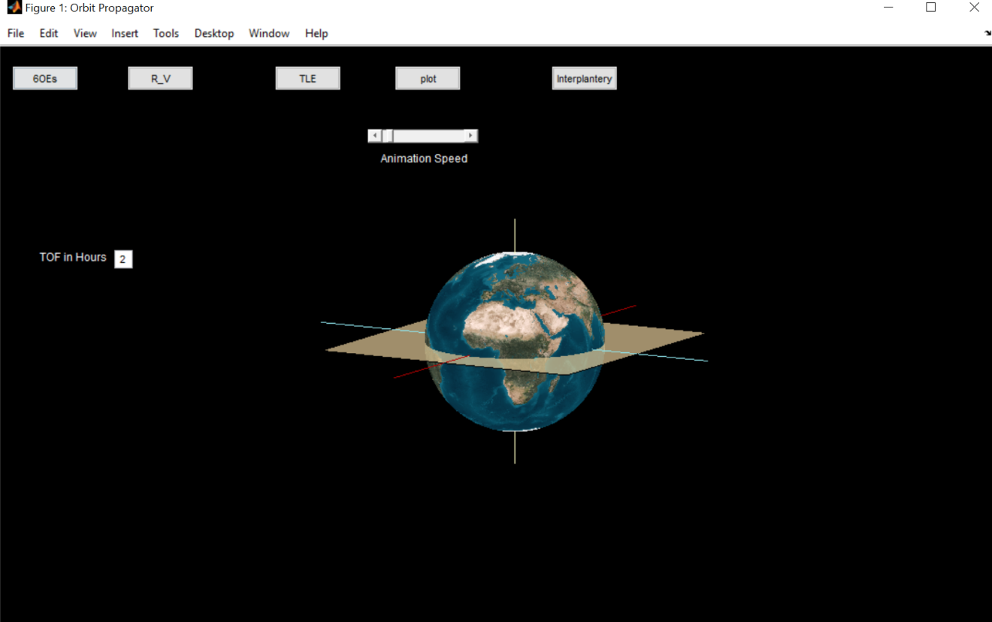

Fig(1)

* This window contains 5 pushbuttons ,a slider and the earth with its Earth centered inertial (ECI) axes and equatorial plane;

1. the first three pushbuttons represent the type of the input depending on the user choice:

a) 6OEs: the six orbital elements.

b) R_V: the initial position and velocity.

1. TLE: the two line element.
2. The fourth pushbutton “plot” is the button that starts the animation
3. The fifth pushbutton “interplanetary” is the button that opens the second window (mode 3) initiating the interplanetary visualization.
4. The slider from which the user can control the speed of the animation.

* Mode (1):

1. The six orbital input:

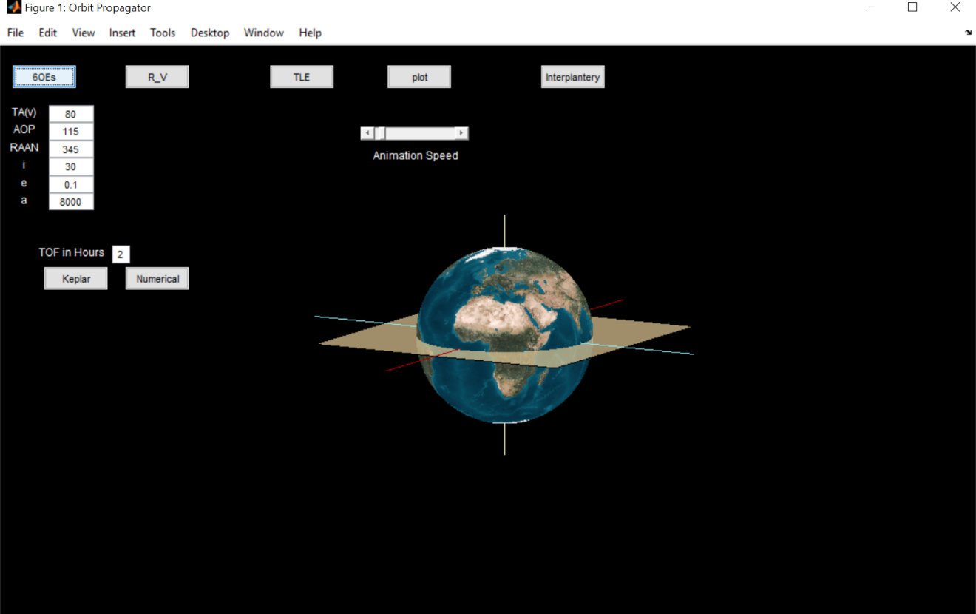

Fig (2)

1- Click on the 6OEs button, 6 editable text boxes will appear in which you can enter the values of the desired orbit.

2-Hit Plot button and the animation starts as shown in fig (3)

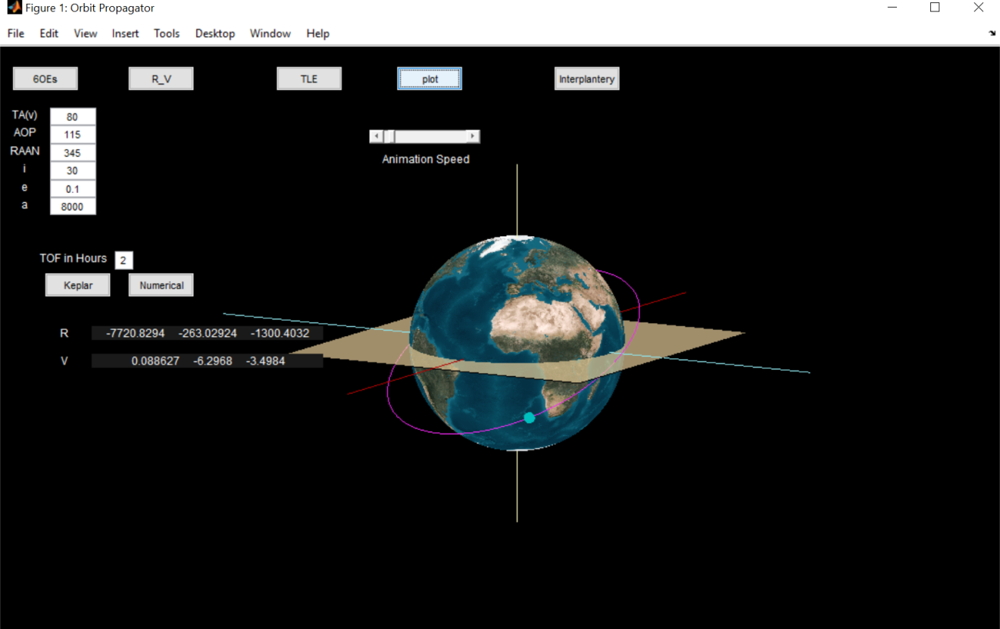

Fig (3)

1. Initial R and V:
2. Click on the R_V button and 2 editable text boxes appear allowing you to enter the initial R and V -AS MATRICES- of the orbit (as shown in fig (4)).
3. Click on Plot button to start the animation.

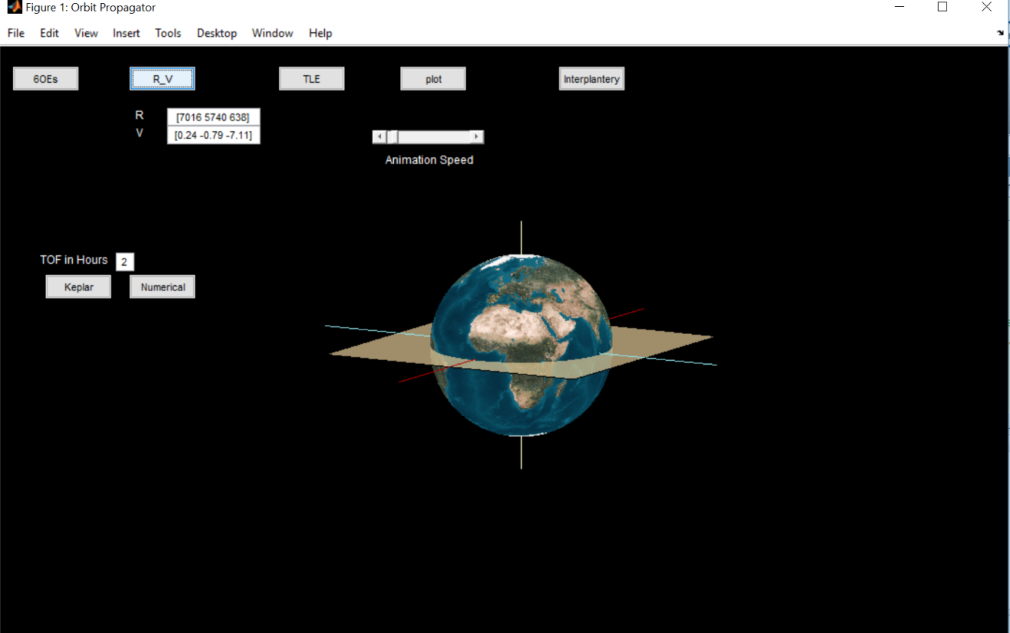

Fig (4)

1. TLE;
2. When you click on the TLE button one editable text box will appear for you to enter the TLE in (fig (5)).
3. Press Plot to show the figure.

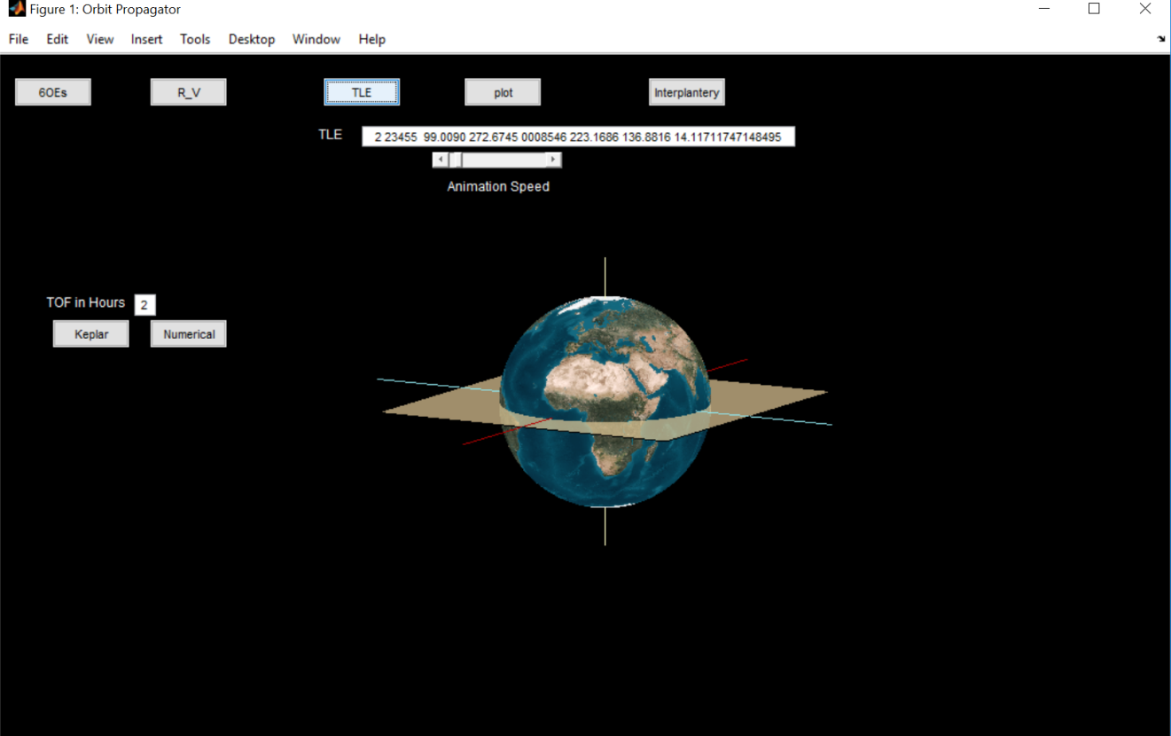

Fig (5)

* TLE examples:

1-2 23455 99.0090 272.6745 0008546 223.1686 136.8816 14.11711747148495

2-2 00005 34.2544 279.4240 1851477 235.3377 105.8748 10.83848344594048

3-2 39482 23.9303 210.5320 6247426 301.6445 12.1811 3.76333605 27464

4-2 00000 72.0000 284.0000 1900000 107.0000 116.691 1.00182731 78888

5-2 00000 38.0000 150.0000 1900000 107.0000 116.691 1.00182731 78888

6-2 00000 112.0000 300.0000 1900000 107.0000 116.691 1.00182731 78888

* Results of mode (1) of the program compared to the STK results;

1-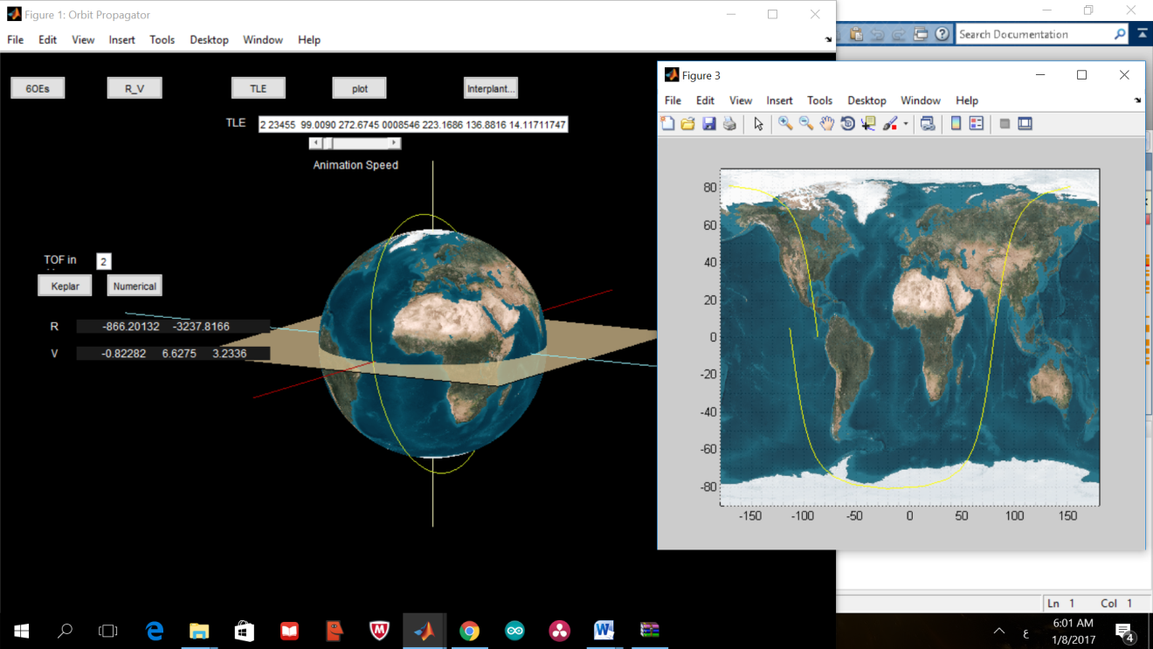

Tle number one tle from output from the program

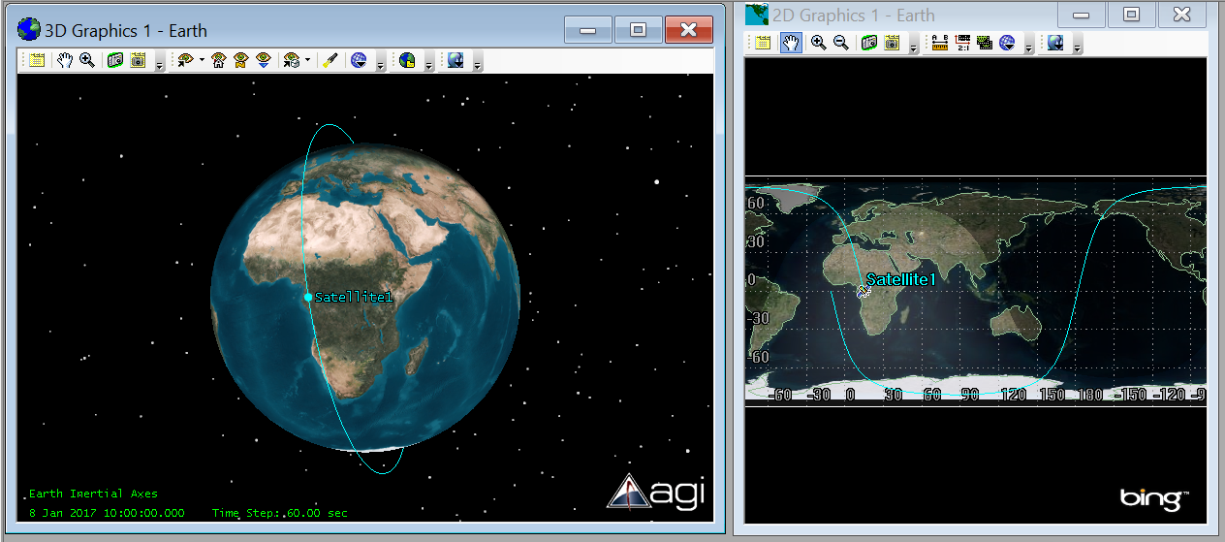

The number one tle from output from STK

2-

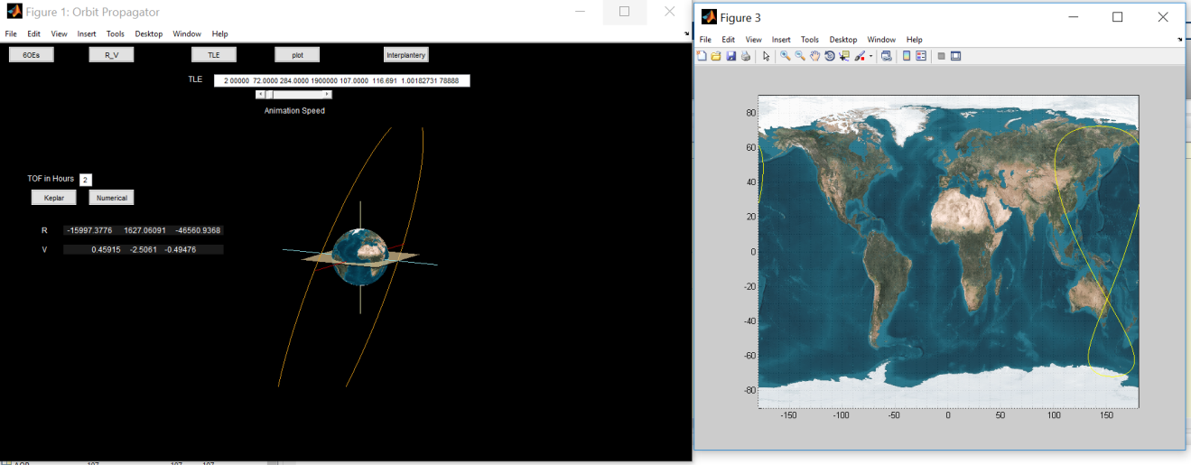

Tle number 4 from our program

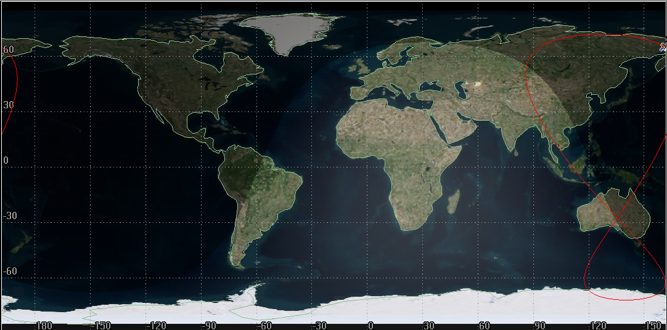

Ground track of tle number 4 from STK (sorry the 3d view wouldn’t zoom so the orbit didn’t appear properly)

* Mode (2)

It gets activated as soon as you enter the input and the required time.

* Mode (3)

Fig (6) shows the default window of interplanetary transfer which appears when you click on “Interplanetary ” button.

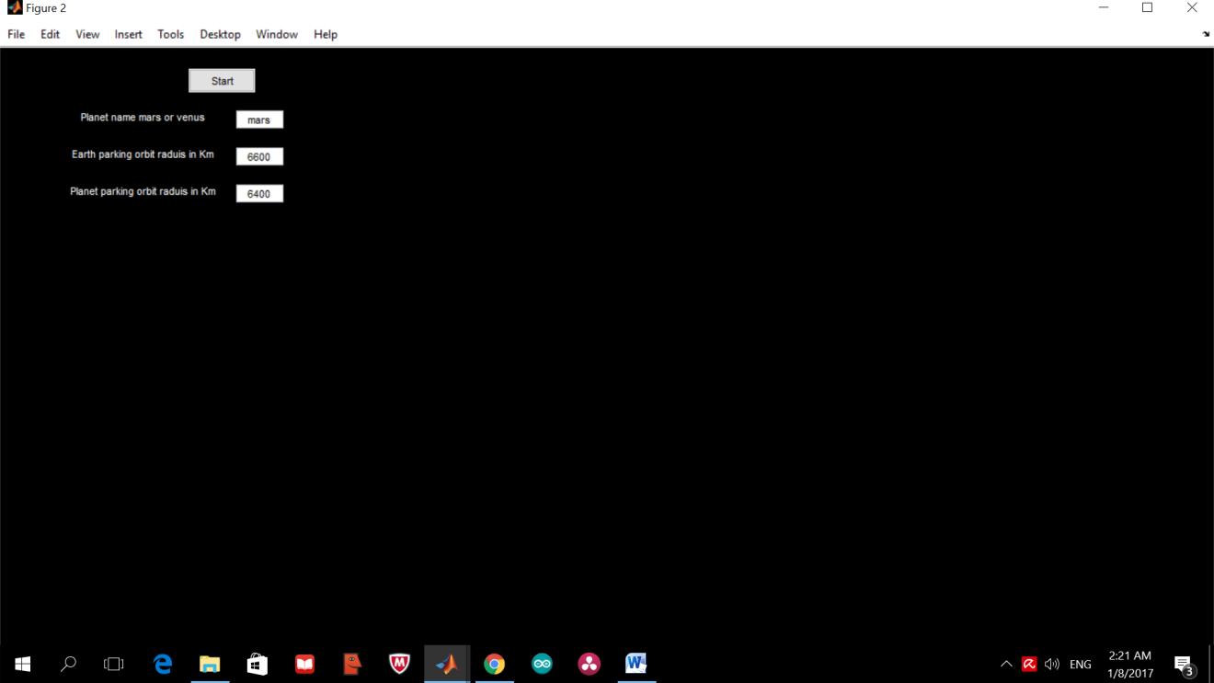

Fig (6)

1. Enter the required input.
2. Press start and the animation starts as shown in fig(7).

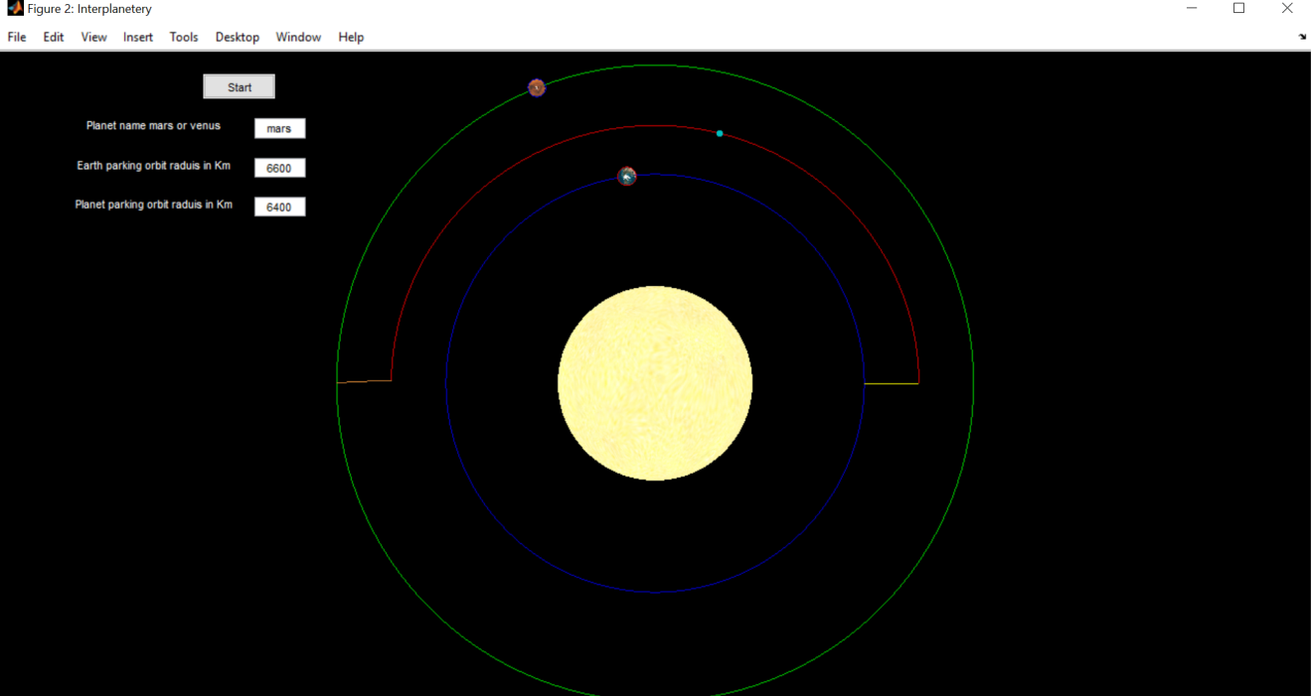

Fig (7): before rendezvous

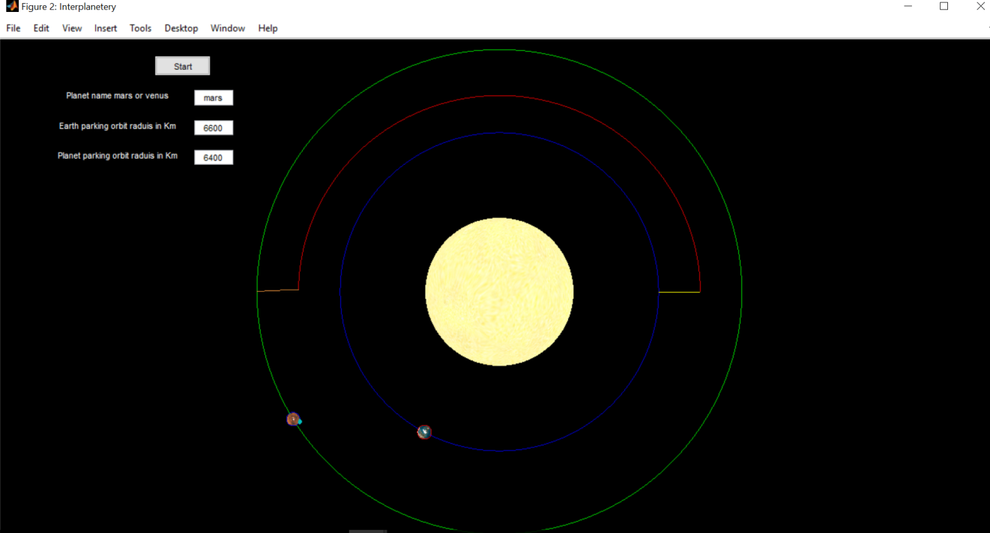

Fig(8): after rendezvous.

Notes:

1. We had to scale the two planets and the satellite in the interplanetary so that they appear in the presence of the sun.
2. The beginning and the end of the transfer orbit appear to be horizontal lines due to the relatively small changes in their y-axis, but if we zoom in they appear natural.
3. The user can use rotate 3d or zoom in from tools in the GUI window.
4. The matlab program is attached with this folder.